1. There are certificate to be installed under filename PTPCA.cer
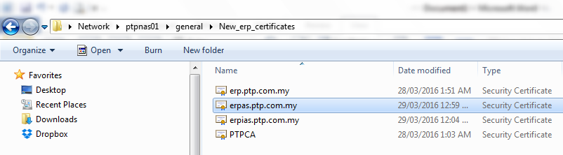
2. Double click on ‘PTPCA’ certificate.
3. Click on ‘Install Certificate’ button.
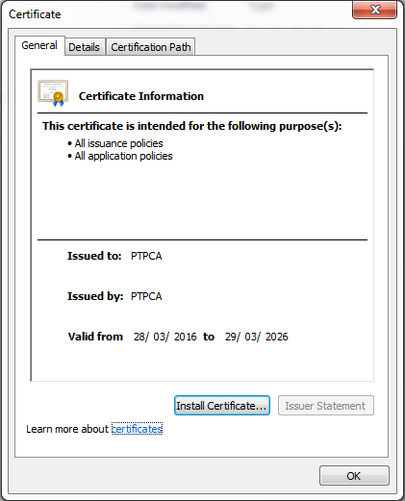

4. Click ‘Next’.
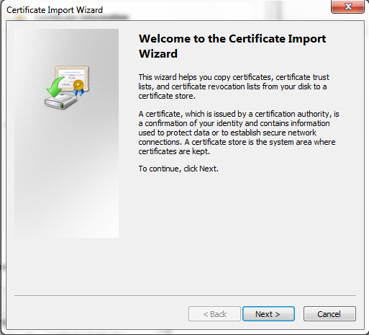

5. Select ‘Place all certificates in the following store’.
6. Click ‘Browse’ button.
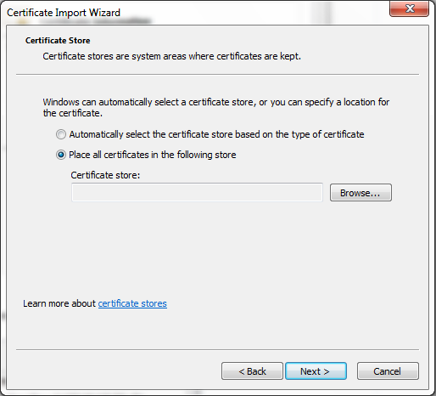

7. Select ‘Trusted Root Certification Authorities’ and click ‘OK’.
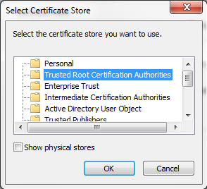
8. Click ‘Next’.
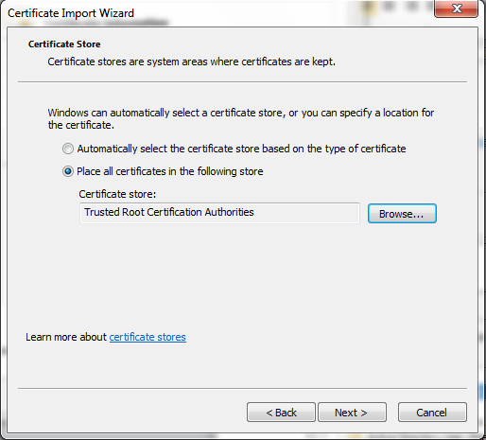

9. Click ‘Finish’.
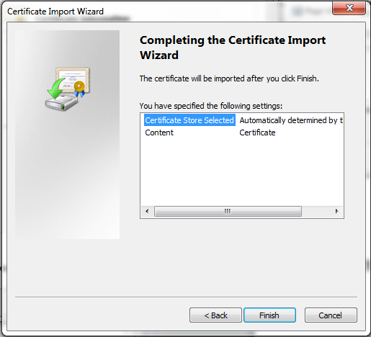

10. Click ‘OK’
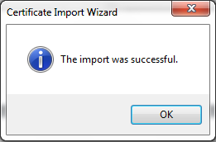

11. Click ‘OK’
