1. There are three certificates to be installed.
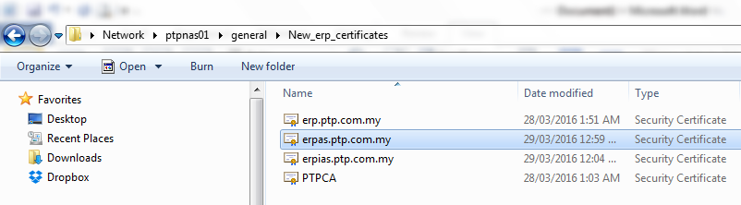
2. Double click on ‘erp.ptp.com.my’ certificate.
3. Click on ‘Install Certificate’ button.
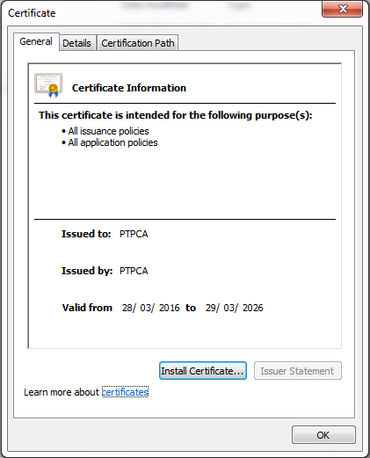
4. Click ‘Next’.
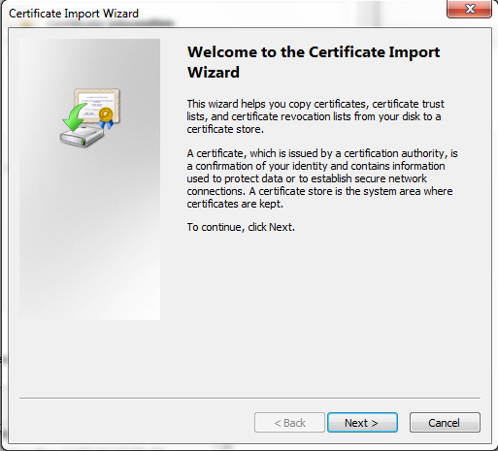
5. Click ‘Next’.
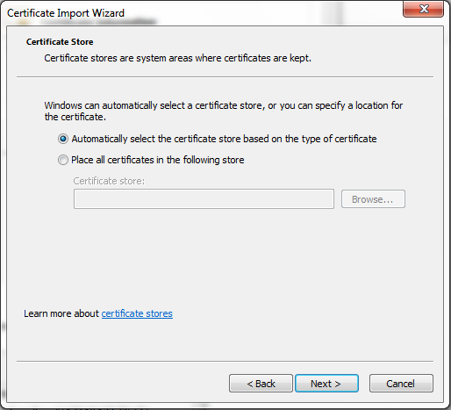
6. Click ‘Finish’.
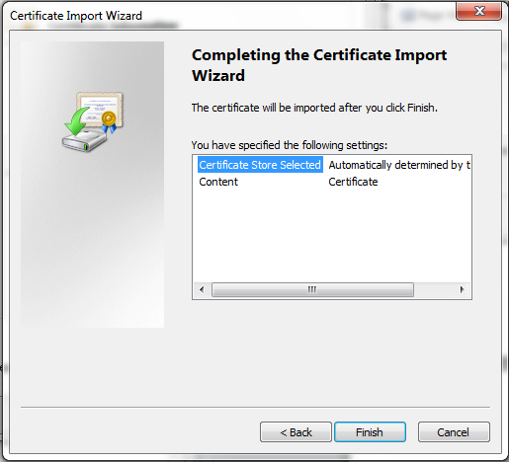

7. Click ‘OK’
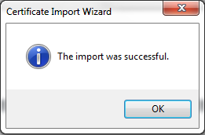

8. Click ‘OK’
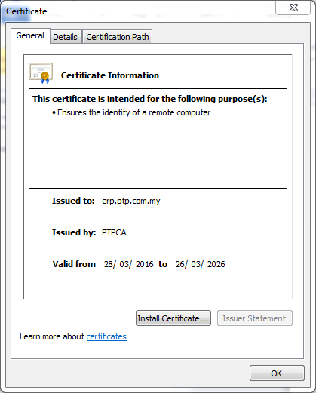

9. Repeat step 3 to 8 for ‘erpas.ptp.com.my’ and ‘erpias.ptp.com.my’.

